Program 1:

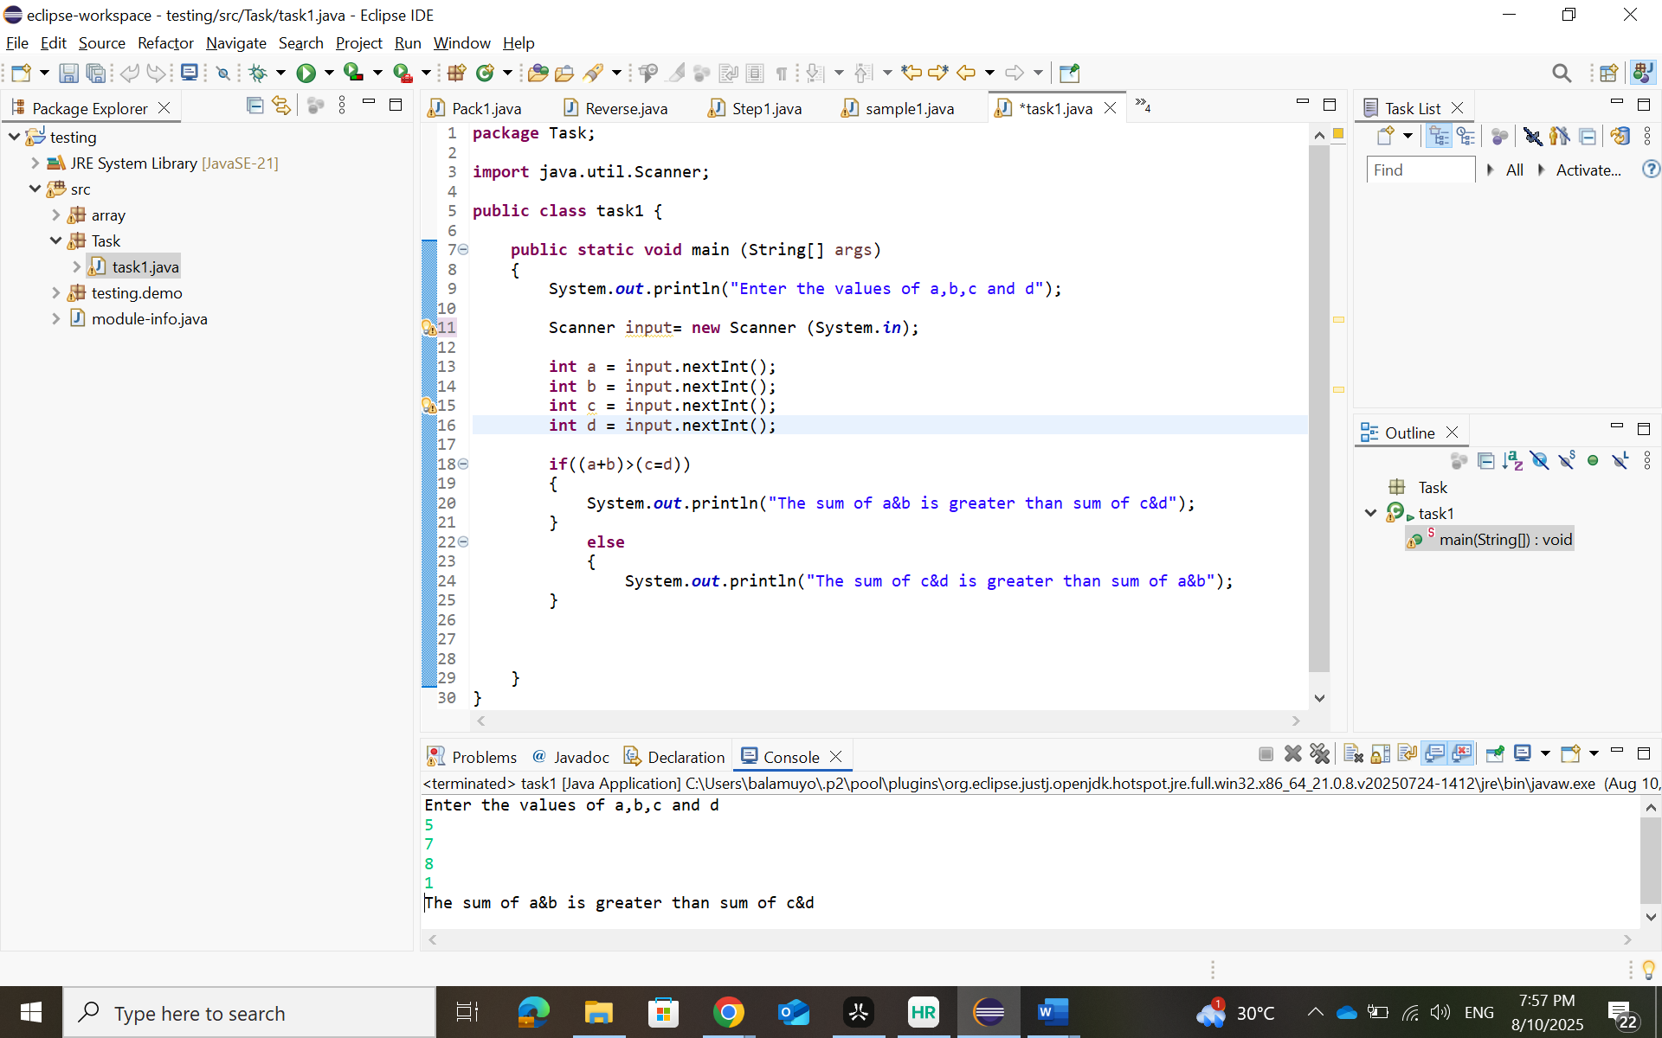

Program 2:

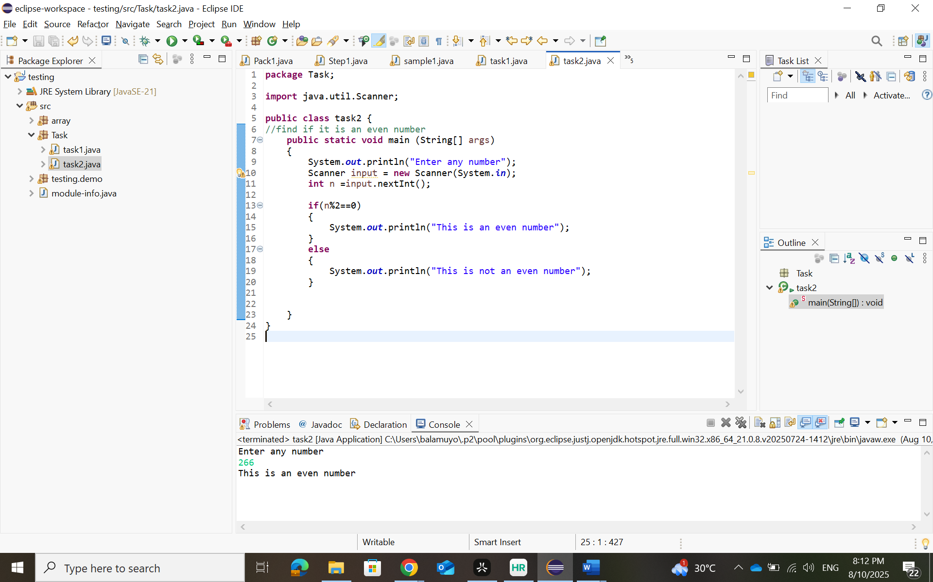

Program 3:

Program 4:

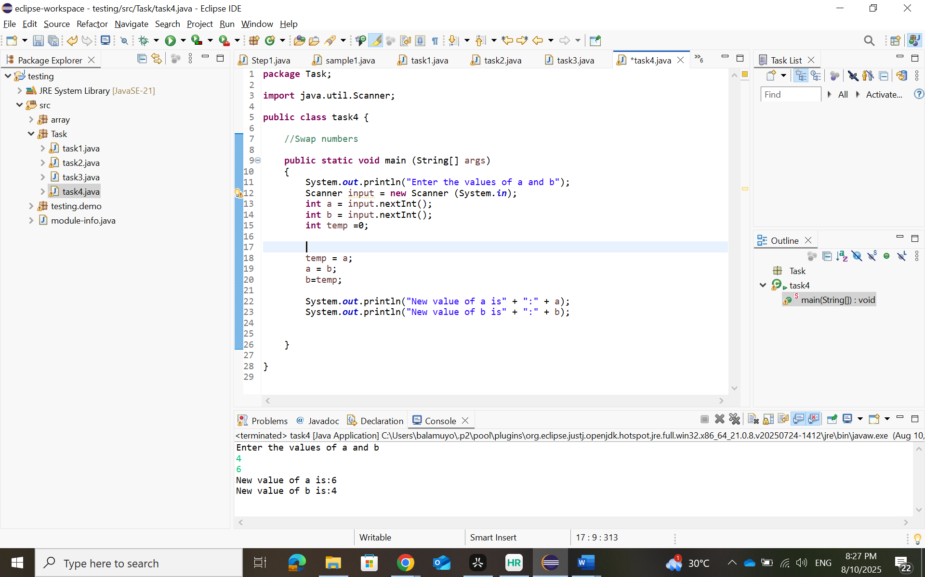

Program 5:

Program 6:

Program 7:

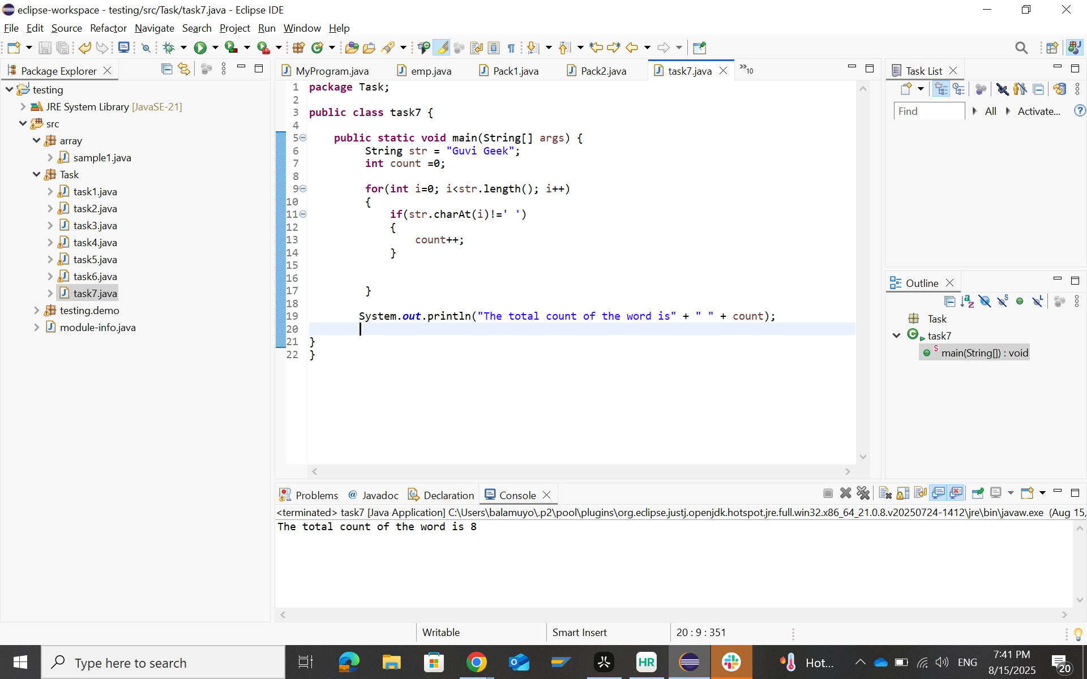

Program 8:

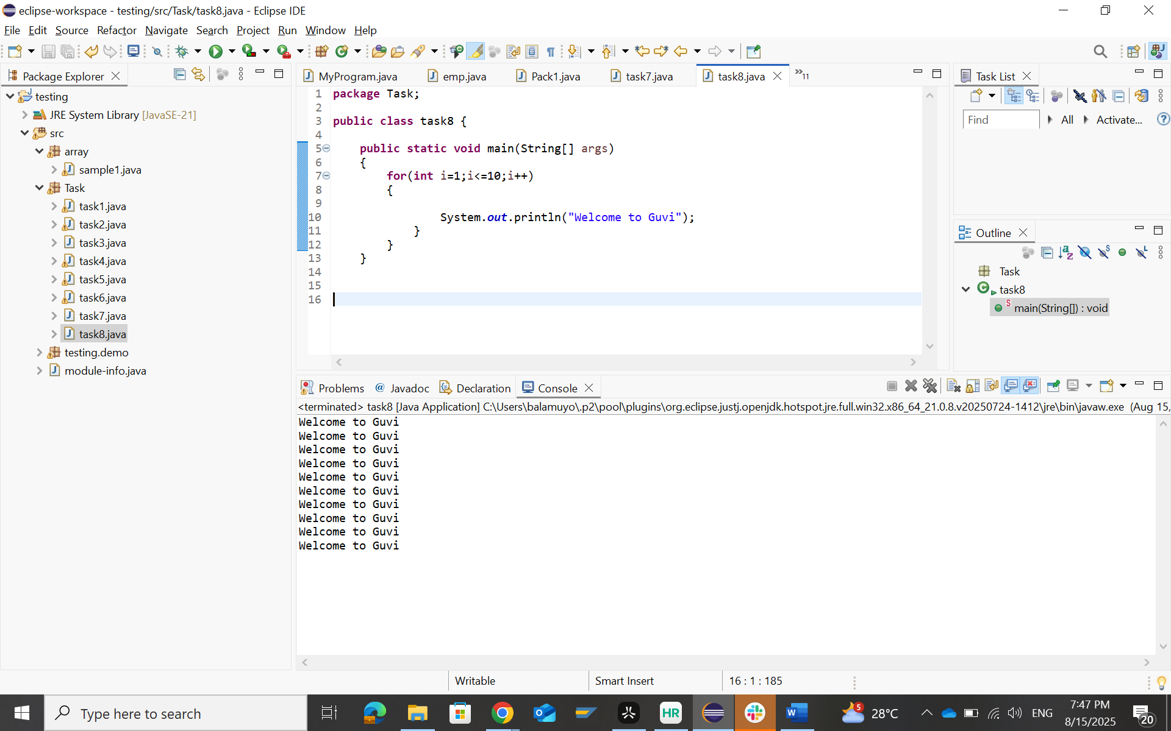

Program 9:

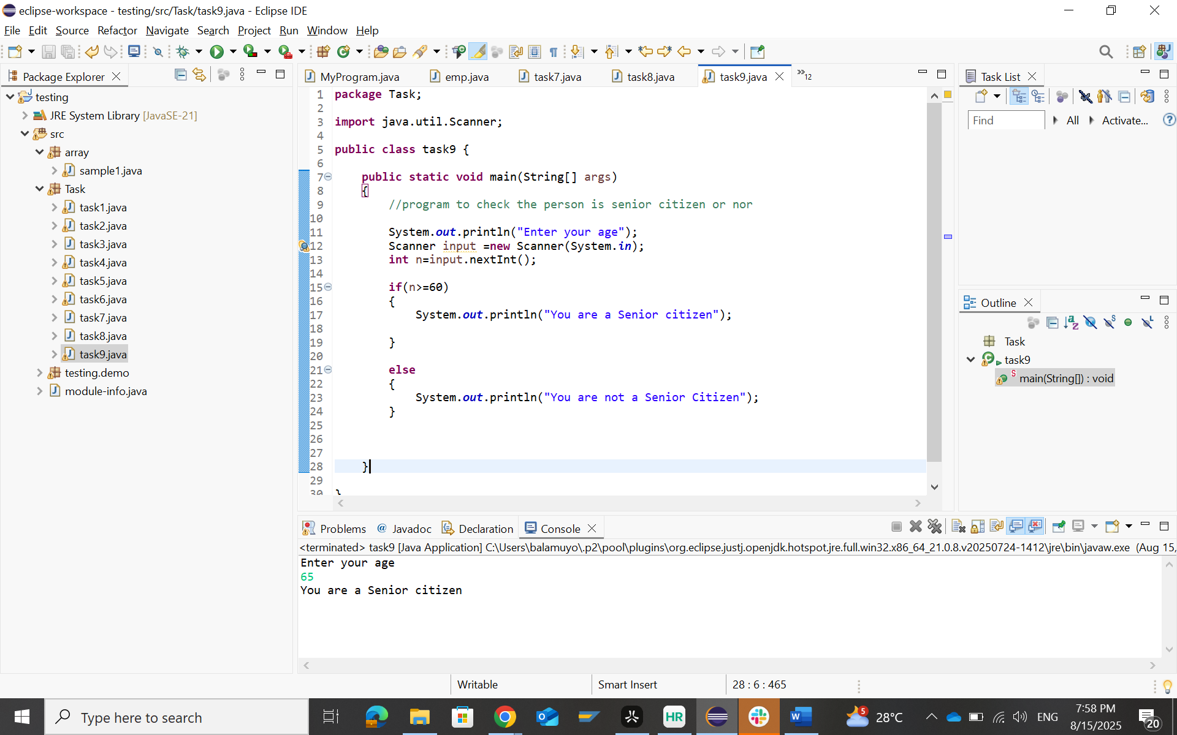

Program 10:

